# **Grub configuration file missing.**

* server struck in error like below image, operating system not found, when grub configuration file missing, by using Linux rescue mode we can reinstall grub os and we can bring the server to the working State.

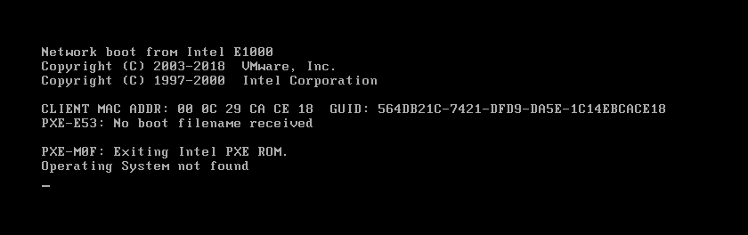

* server surpassed the BIOS stage because console screen is appeared.
* To check server is surpassed the MBR, go to console, power on the server through firm ware option.

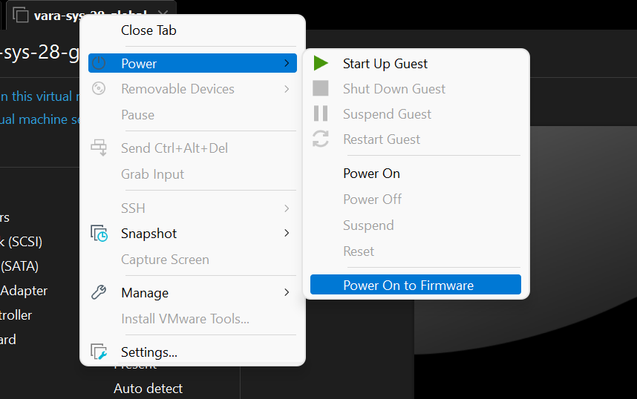

* We can see BIOS set up utility in below screenshot.

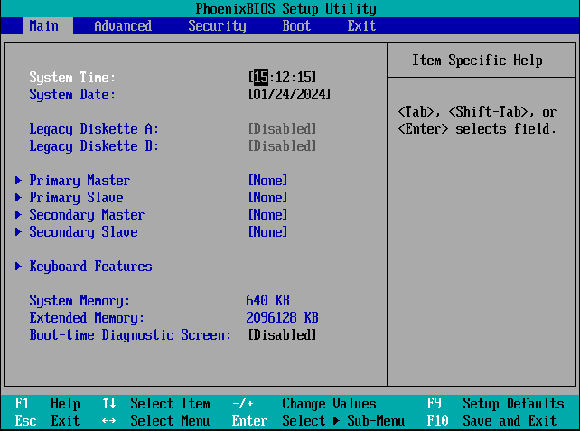

* Now select boot the option

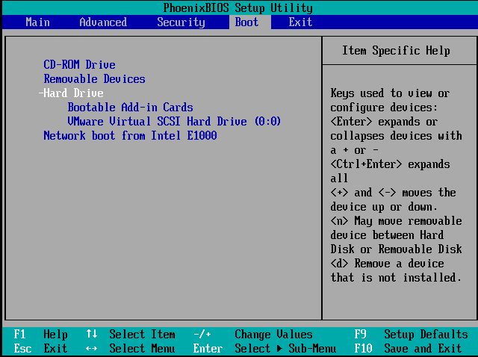

* Attach respective ISO image to boot up with to the server.

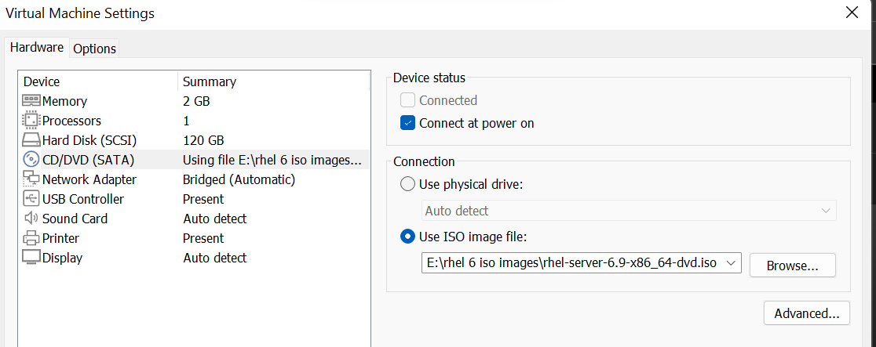

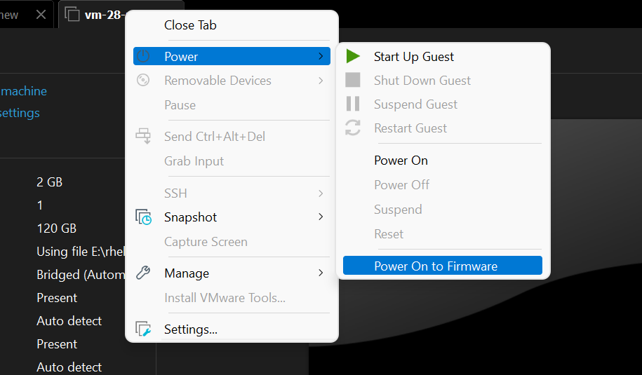

* We have to boot the server with CD-ROM, to do that we have to change the booting sequence as shown below.
* follow the instructions select appropriate options and save the configuration changes.

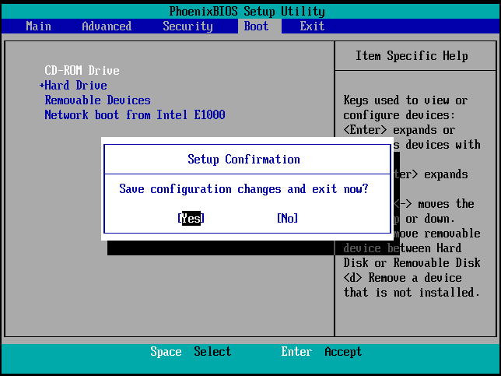

* In below screen select **rescue installed system** option by navigating with arrow keys.

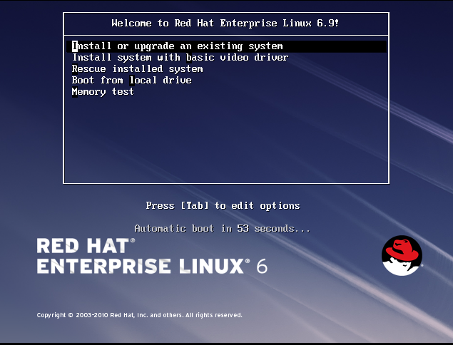

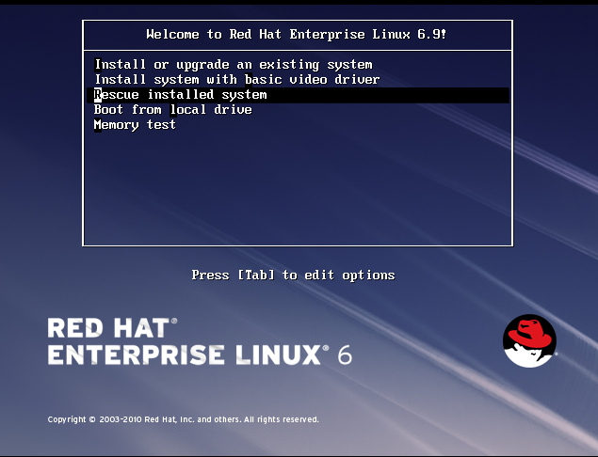

* Select default language and key board settings on successive screens respectively.

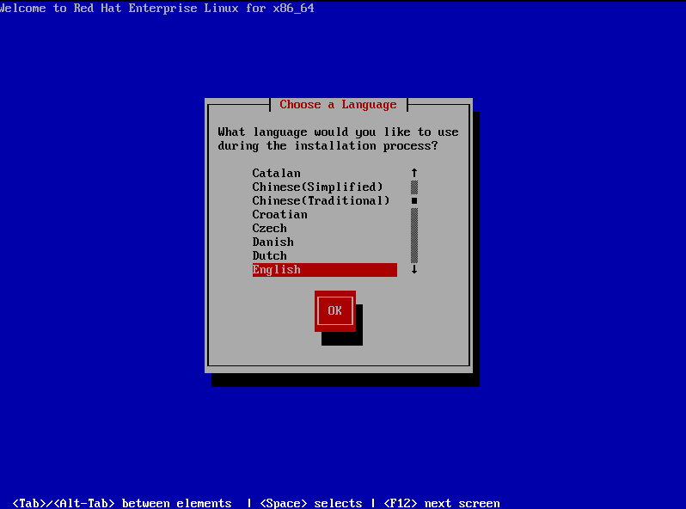

* select no in below screen.

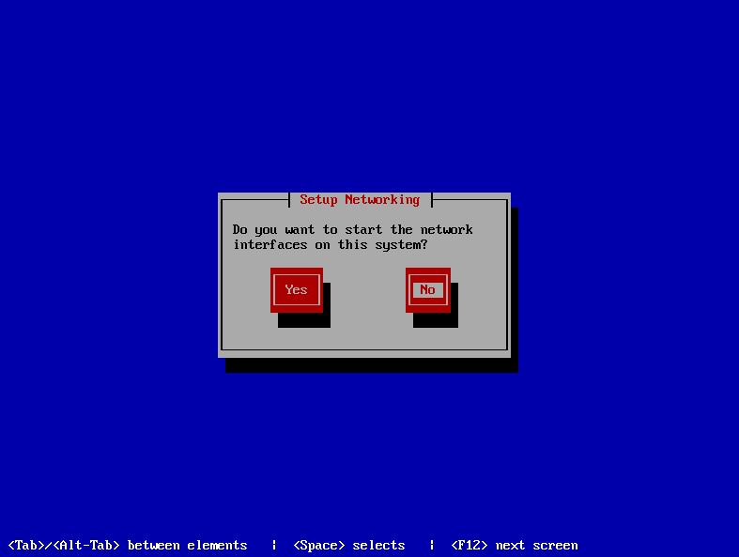

* Select continue option to mount the filesystems in **/mnt/sysimage.**

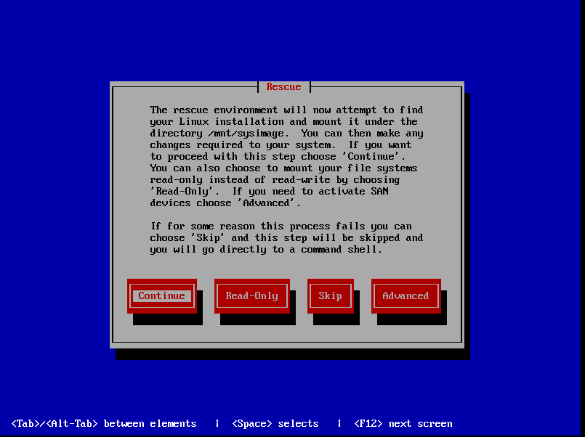

* Now system is mounted under **/mnt/sysimage**, select **OK** option.

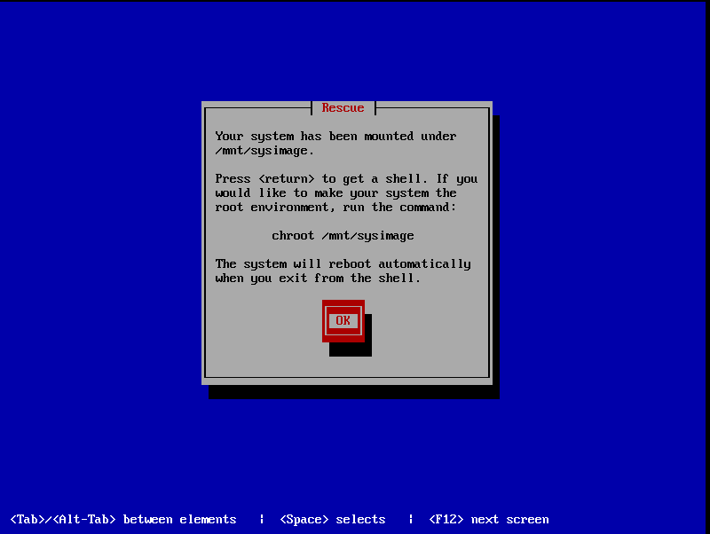

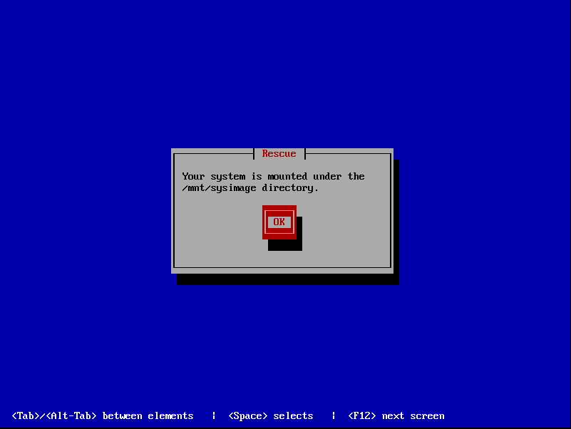

* On below screen by selecting **shell start shell** and Ok options it will give shell to execute commands.

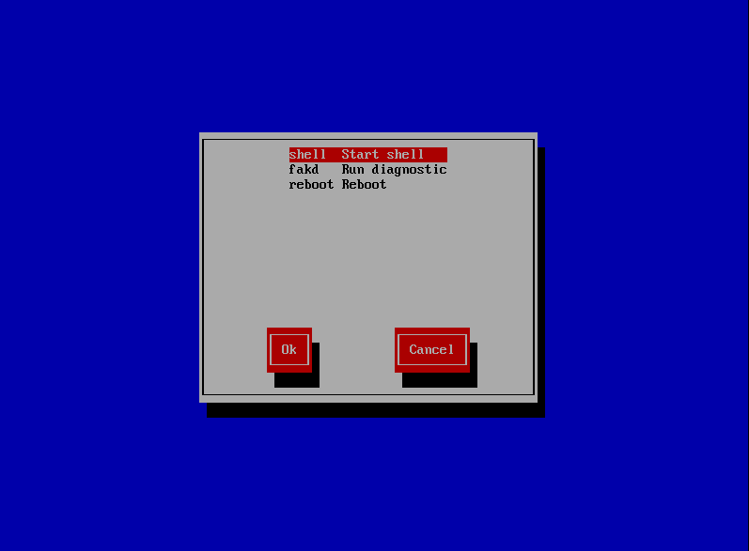

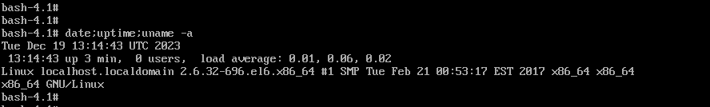

* In **df -h** command we can observe that file systems are mounted under

**/mnt/sysimage.**

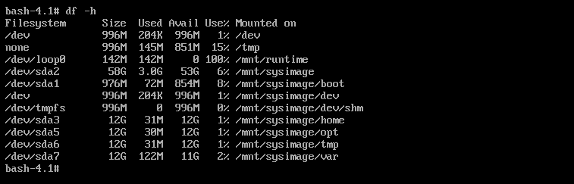

* To get the system to root environment execute the command. See below image. And after command executed check **df -h** file systems are in root environment.

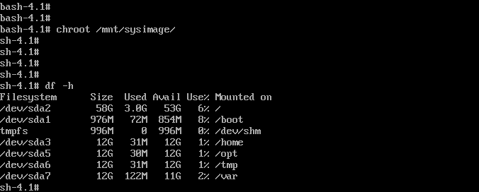

.

* To install grub os execute the below command, we can see that grub os is successfully installed.

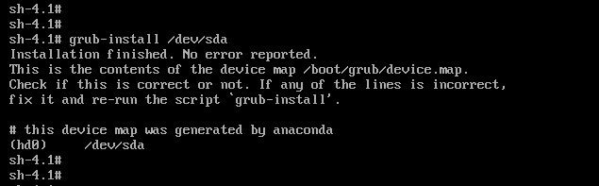

* Detach the iso image.

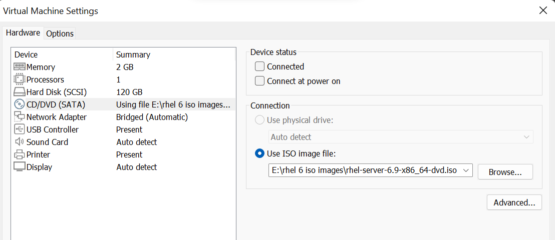

* Now reboot the server in linux rescue mode leads to grub os screen.
* Only particular set of commands can execute in this screen.
* If we use boot command, it shows error kernel is not loading.
* In the absence of grub configuration file, grub unable to read the /boot file system which contains both kernel image and initrd image.

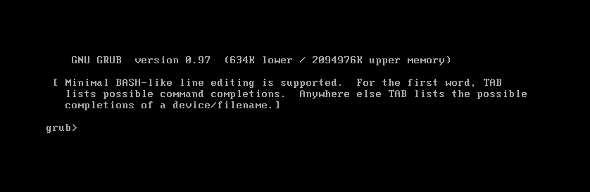

* To bring the server to original state we have to load the kernel manually by following commands in grub os screen.

# 

* Now by using boot commands server boots up, but it is temporary.
* If we reboot again it will go to grub os screen, this issue is because of grub configuration file does not exists.
* We have to recover grub configuration file.

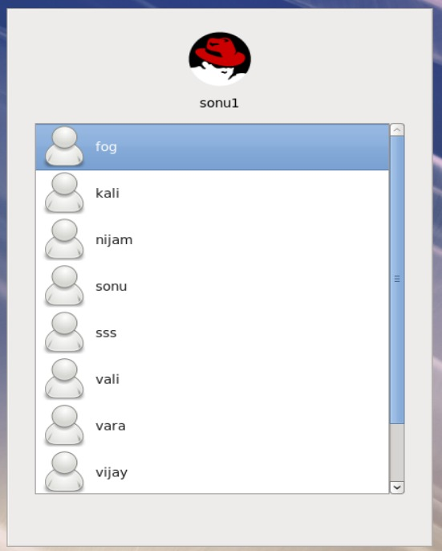

* we have recover grub configuration file and modify accordingly with UUID of /dev/sda2.
* From any other server deployed from same clone, copy grub configuration file by using **scp** command.

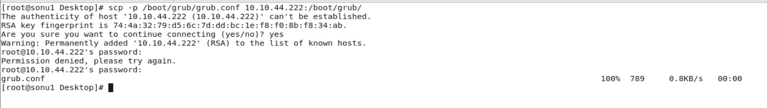

* Open the grub configuration file in **vara-global-44** server, and modify it with same parameters such as UUID of /dev/sda2 in grub configuration file.

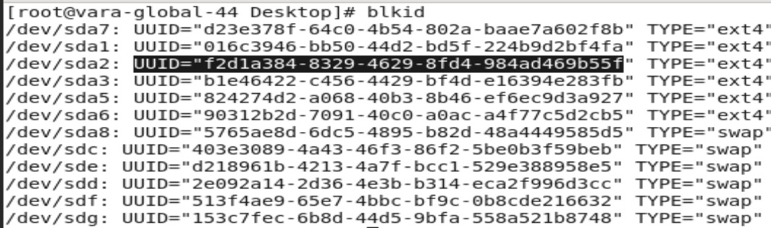

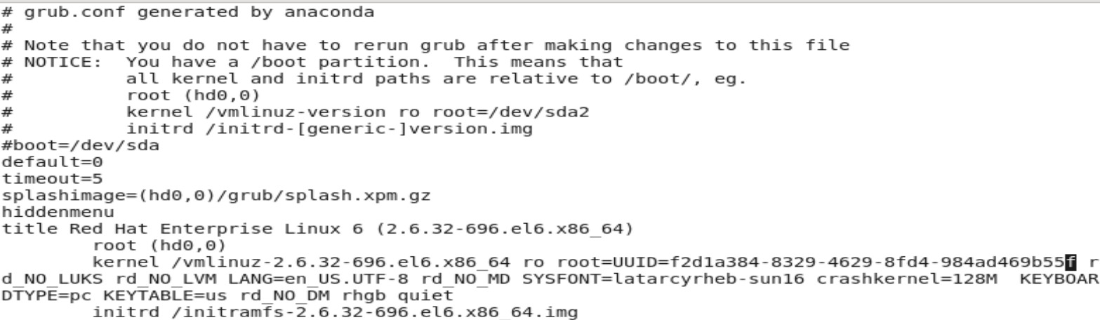

* grub configuration file is modified with UUID of root file system.



* we reboot now server pasts the grub os screen, server is up and running fine as above screenshot.

# 